**LAB # 12**

**Task1: Retrieve Salary by country along with grand total by rollup**

**Query:**

select country, sum(salary) as TotalSalary from employees group by rollup(country)

**Output:**

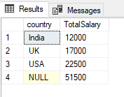

**Task 2:** **Create the result table and generate the output applying rollup query:**

**Table name: result**

**Query:**

select Class,Section,sum(marks) as TotalMarks from result group by rollup(Class,Section)

**Output:**

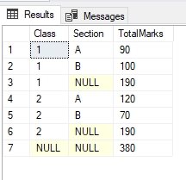

**Task3: Write a query to retrieve Sum of Salary grouped by all combinations of the following 2 columns as well as Grand Total. Country, Gender?**

**Query:**

select Country,Gender,sum(salary) as TotalSalary from employees group by rollup(country,gender)

**Output:**

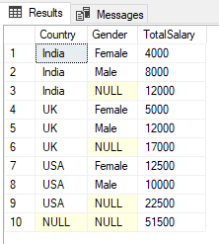

**Task 4: Generate the output applying cube query:**

**Query:**

select Class,Section,sum(marks) as TotalMarks from result group by cube(Class,Section)

**Output:**

